**CHAPTER 6: USING THE COMMON WIDGETS**

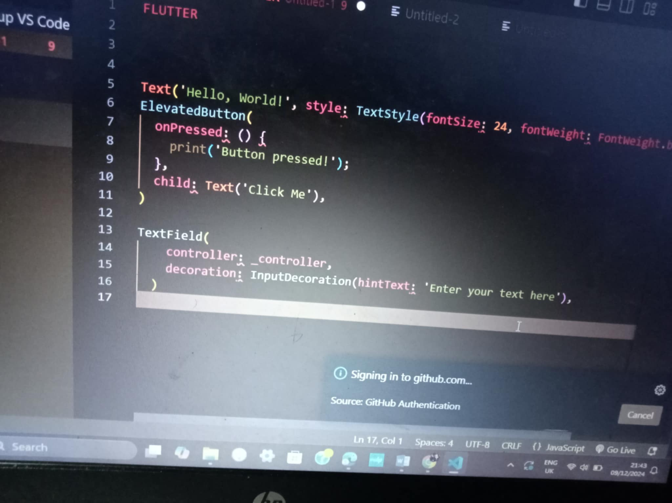In the context of software development, especially for mobile or web development, **common widgets** typically refer to the basic UI elements that allow users to interact with the application. These can include buttons, text inputs, checkboxes, sliders, and more. The specific widgets you use depend on the framework or platform you're working with. Below are examples for different platforms: